Title | Web Scraping and Data Collection
Problem Statement | Scrape data from a webpage and store it in a structured format like CSV or JSON format
Objectives | • To understand the concept of web scraping and data collection.  • To retrieve webpage content using the Requests library.  • To extract required information from HTML using BeautifulSoup.  • To organize the scraped data using Pandas DataFrame.  • To store the collected data in structured formats such as CSV and JSON.
Dataset  URL Link /  File | https://quotes.toscrape.com
Function Details | Sl. No. Function Package Description of Function  1 requests.get() requests Retrieves the HTML content of a webpage  2 BeautifulSoup() bs4 Parses the HTML content of the webpage  3 find_all() BeautifulSoup Finds all matching HTML elements  4 find() BeautifulSoup Finds the first matching HTML element  5 DataFrame() pandas Converts collected data into tabular format  6 to_csv() pandas Stores data in CSV format  7 json.dump() json Stores Python data in JSON format  8 json.load() json Reads data from a JSON file
Steps/  Process/  Procedure/  Algorithm/  Flowchart/  Model | 1. Import the required libraries: requests, BeautifulSoup, pandas and json.  2. Specify the URL of the webpage to be scraped.  3. Send an HTTP GET request using requests.get().  4. Parse the HTML content using BeautifulSoup.  5. Locate the required HTML elements containing quotes, authors and tags.  6. Extract the required data from the webpage.  7. Store the extracted data in a Python list.  8. Convert the collected data into a Pandas DataFrame.  9. Save the structured data in CSV format using to_csv().  10. Save the same data in JSON format using json.dump().  11. Display the collected data to verify the output.
Program | import requests  from bs4 import BeautifulSoup  import pandas as pd  import json  url = "https://quotes.toscrape.com/"  response = requests.get(url)  print("Status Code:", response.status_code)  soup = BeautifulSoup(response.text, "html.parser")  print("Website Title:", soup.title.text)  quotes = []  for item in soup.find_all("div", class_="quote"):  quote = item.find("span", class_="text").text  author = item.find("small", class_="author").text  tags = [  tag.text  for tag in item.find_all("a", class_="tag")  ]  quotes.append({  "Quote": quote,  "Author": author,  "Tags": ", ".join(tags)  })  print("Number of quotes collected:", len(quotes))  df = pd.DataFrame(quotes)  df  df.to_csv("quotes.csv", index=False)  print("Data saved successfully in CSV format.")  with open("quotes.json", "w", encoding="utf-8") as file:  json.dump(quotes, file, indent=4, ensure_ascii=False)  print("Data saved successfully in JSON format.")  csv_data = pd.read_csv("quotes.csv")  csv_data  all_quotes = []  page = 1  while True:  url = f"https://quotes.toscrape.com/page/{page}/"  response = requests.get(url)  soup = BeautifulSoup(response.text, "html.parser")  items = soup.find_all("div", class_="quote")  if not items:  break  for item in items:  quote = item.find("span", class_="text").text  author = item.find("small", class_="author").text  tags = [  tag.text  for tag in item.find_all("a", class_="tag")  ]  all_quotes.append({  "Quote": quote,  "Author": author,  "Tags": ", ".join(tags)  })  page += 1  print("Total quotes collected:", len(all_quotes))  df = pd.DataFrame(all_quotes)  df  df.to_csv("quotes_dataset.csv", index=False)  with open("quotes_dataset.json", "w", encoding="utf-8") as file:  json.dump(all_quotes, file, indent=4, ensure_ascii=False)  print("CSV and JSON files created successfully.")
Output Snapshots  With  Explanation/  Observations | The required libraries requests, BeautifulSoup, pandas and json are imported for web scraping, HTML parsing, data organization and structured data storage.  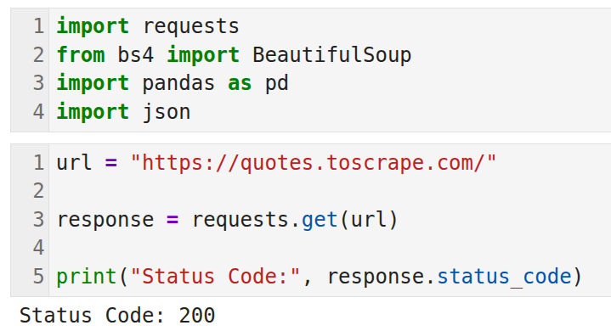Fig. 1.1: Importing Required Python Libraries  The webpage https://quotes.toscrape.com/ is accessed using requests.get(). The status code 200 confirms that the webpage was successfully retrieved.  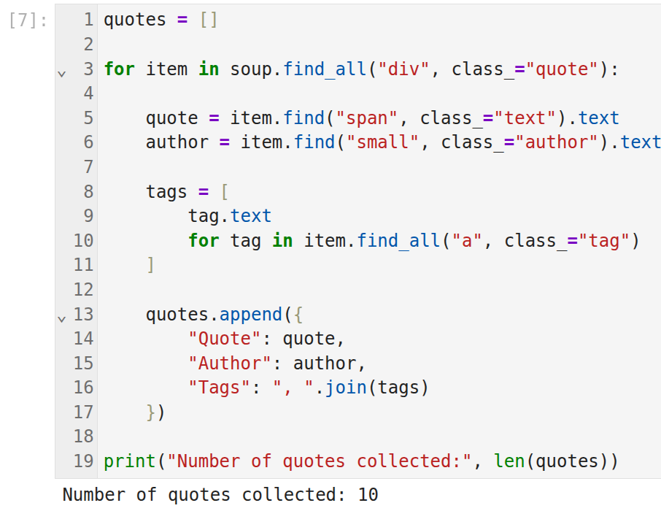Fig. 1.2: Accessing the Webpage  The HTML content of the webpage is parsed using BeautifulSoup. The webpage title confirms that the correct page has been successfully loaded.  The scraped data is successfully stored in CSV format using the pandas to_csv() function.  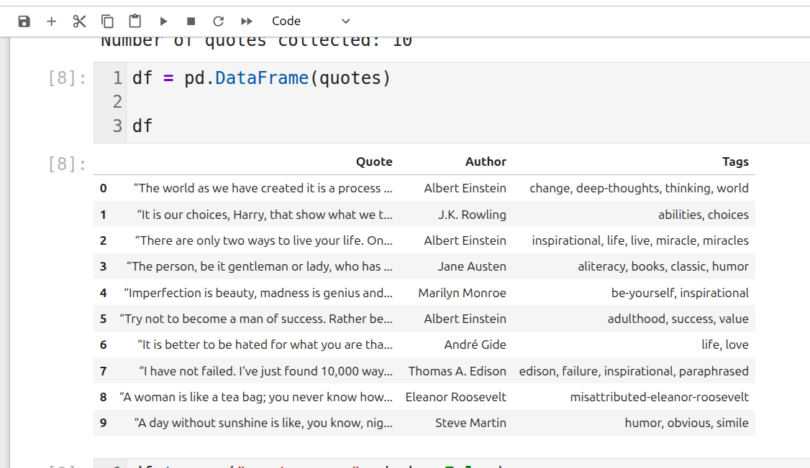Fig. 1.3: Parsing the HTML and displaying the dataset Content  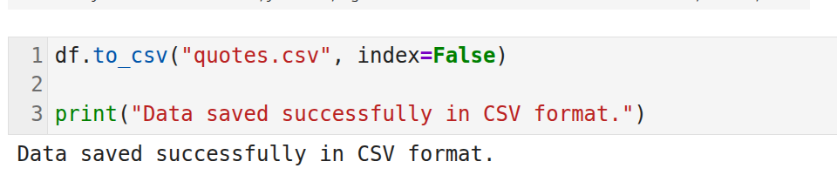Fig. 1.4: Saving Data in CSV Format  The scraped data is successfully stored in JSON format using the json.dump() function.  The scraped data is successfully stored in JSON format using the json.dump() function.  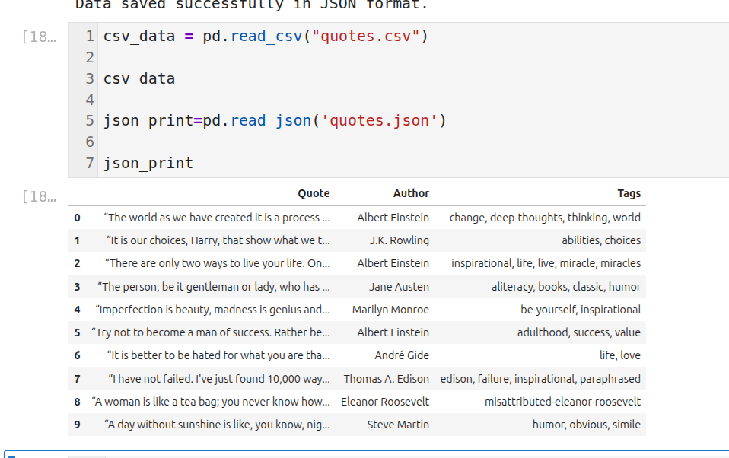Fig 1.6: Displaying the saved json and csv  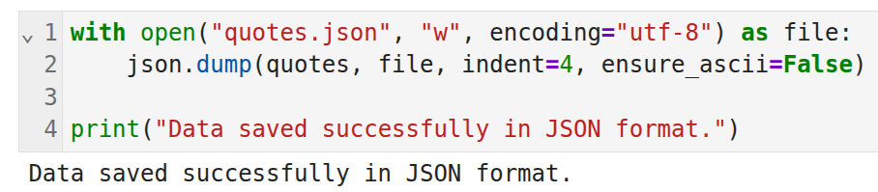Fig. 1.5: Saving Data in JSON Format  The saved CSV file is read using pandas.read_csv() and displayed to verify that the data has been stored correctly.  The saved JSON file is read using json.load() and the stored records are displayed successfully, confirming correct JSON storage.
Conclusions | The experiment was successfully completed by scraping data from the given webpage using Python. The webpage content was retrieved using the requests library and parsed using BeautifulSoup. The required information such as quotes, authors, and tags was extracted and organized using a Pandas DataFrame. Finally, the collected data was successfully stored in structured CSV and JSON formats for further analysis and use.
References | - Michael Freeman and Joel Ross, Programming Skills for Data Science: Start Writing Code to Wrangle, Analyze, and Visualize Data with R, Addison-Wesley, 2018  - Python Program (Google Colab link /Githab link)  - Class lecture link

